**Objectives**

•         Create a list of negative test conditions for payment by Credit card process

**Type of activity**

•         Individual activity

**Requirements**

Application provides you option to pay using credit card / debit card as follows.

http://192.168.1.7/Inpods/Hands-On%20Exercises/Assignment%20-%20Identify%20Negative%20test%20conditions_files/image001.png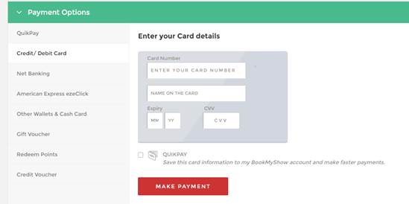

After this screen, system takes you to the bank screen where it asks for one time password sent on your registered mobile number. If it is entered correct payment is made.

**Write negative conditions in the form of**

“To check error when ****”

Identify all negative conditions where

1.     User enters incorrect data

2.     User behaves incorrectly